**ASSIGNMENT-3**

**DESIGN AN INTERACTIVE VISUALIZATION SYSTEM**

**Sai Varun Teja Mudumba**

**Student ID:11252193**

1. The Interactive Visualization System that I’ve designed can plot the trees on the map based on the locations that users pick to plot and give the intersection of both the locations that fall within a radius can be plotted by following certain instructions. The user needs to select a Location 1 and Location 2 and can specify the radius for both the locations which will plot all the trees that fall within the specified radius and that can be seen in the respective windows. Location 1 and Location 2. And the visualization system also offers the users if they want to find out what trees fall in both the locations with specified radius. But because of certain limitations in Tableau it may be achieved by following certain instructions. After selecting the Locations and Radius for both the locations, users need to select all the points in Location 1 window and add them to a Set 1. Need to do the same even for Location 2 and need to add it to Set 2 when executing it for the first time. But for further executions we need to clear the sets first. This can be done by again selecting all the points from Locations 1 and 2 and by clicking remove from set it will delete the elements from the respective sets. Then the user can change the location and perform the above instructions to find out the intersections. Otherwise they can create a different set every time and they need to go to the Intersection sheet and create a combined set by selecting both the sets and specify just the intersection. Dragging the Combined set over the map will display the results on the map and the same is reflected even on the dashboard. And the system also has some filters such as species and diameter of trees which can be filtered using the filters present on the right panel.
2. The Visualization system is designed using multiple sheets such as Location 1 which plots the trees that are around the location that the user chooses and within the mentioned radius by the user. The sheet Location 2 is used to implement the same for Location 2. This action is implemented by creating parameters and calculation fields for identifying the points and distance to calculate the distance to all other points from the selected points. The sheet Intersection is used to plot the Intersection part of both the sets by forming the combined set. Another sheet “The Different Species listed along with their addresses with additional filters” is provided which has a set of various filters and provides functionalities such as Filtering all the trees according to the species, Site Info, Diameter of the Breast Height and it also displays different sites using different shapes that helps users to distinguish, different colors to distinguish different species and the option of panning and zooming to have a clear view of the results and it also has an option to mark the interested trees by using the mark option. The system creates visualizations according to the applied filters which helps in implementing all the techniques and they are explained below.

**Select:**  
The visualization system allows users to highlight a species of trees with the help of the bar on the right and mark them with a label which displays the dimensions according to the wish of the user.

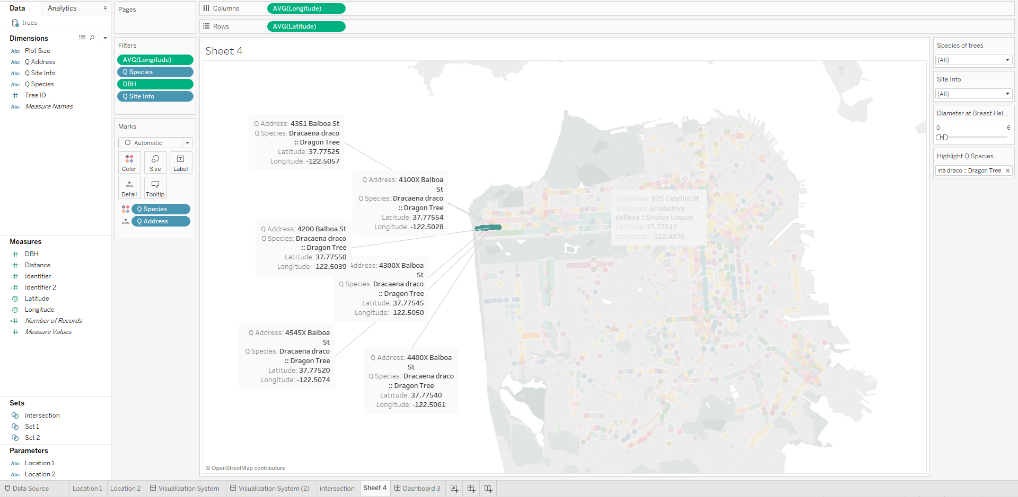

The above picture highlights a certain species of trees among all the others and they are marked using labels along with the information regarding those certain trees.

**Explore:**  
The visualization system allows users to scroll or click the options on the left top to zoom in and have a clear look at what they want to have a look at.

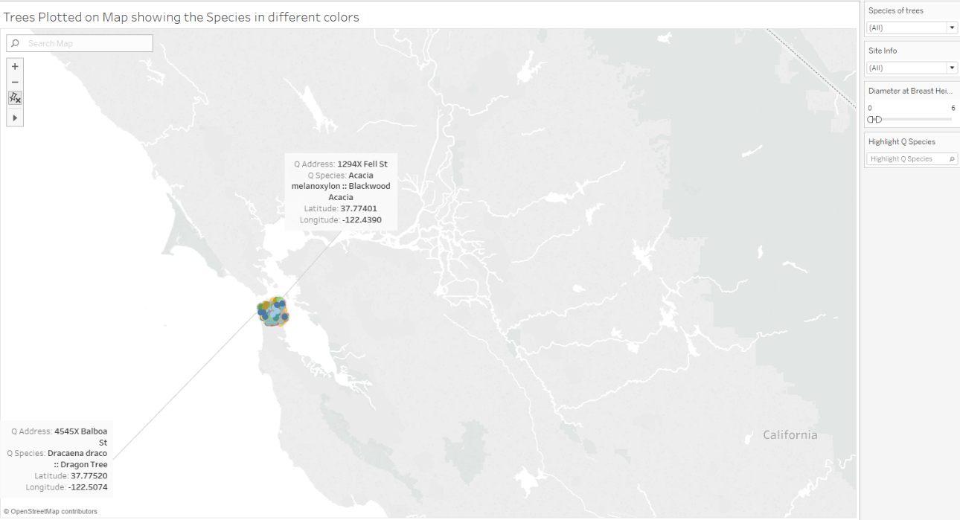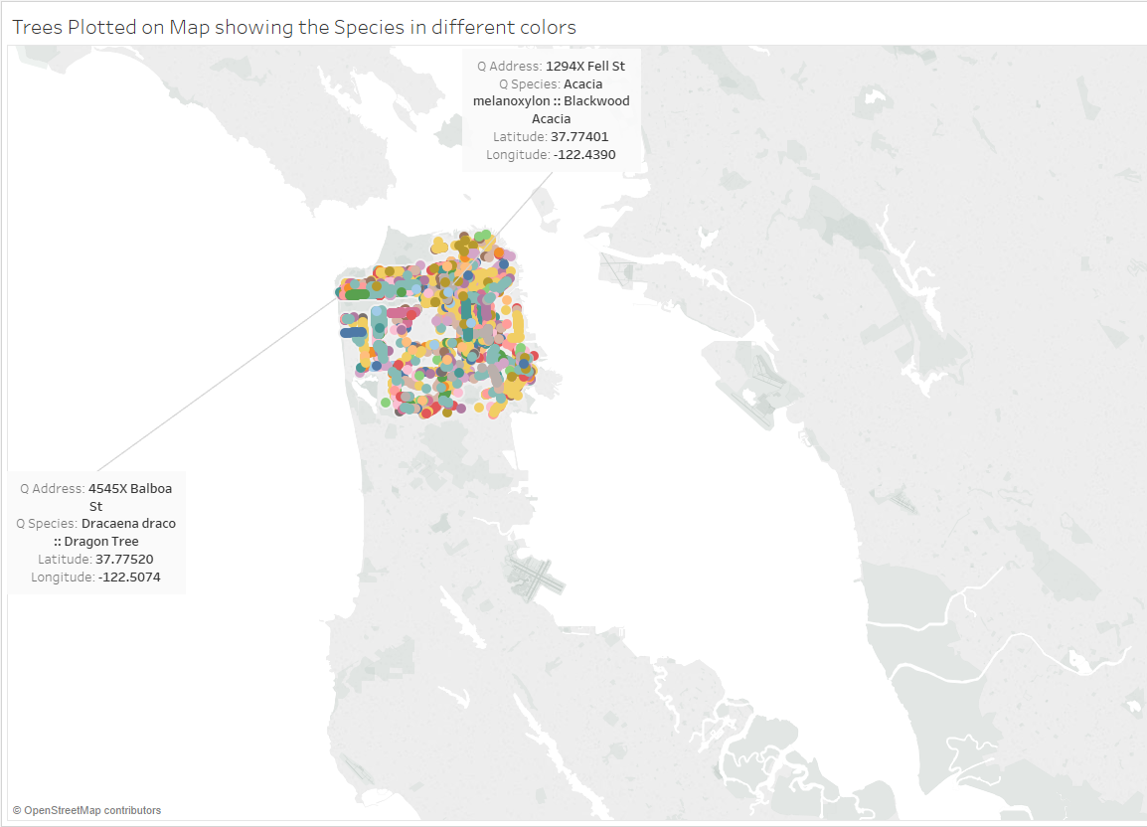  
  
The above figure shows the before and after images of the map which enables the users to look around and explore data with greater insights.  
  
**Reconfigure:**The visualization system allows users to select the dimensions and measures listed on the left and place them on rows and columns to produce various types of visualizations that are being displayed on the top right corner. The below image lists the different species along with their addresses in multiple rows.

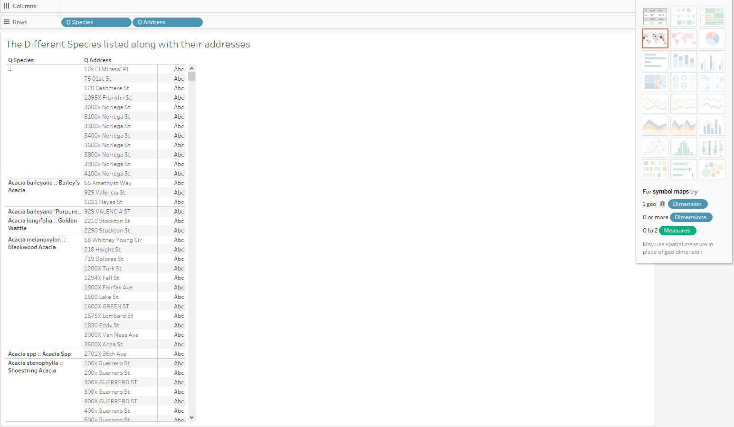  
  
**Encode:**  
The Visualization System allows the users to look at different elements using various visual elements such as different colors, shapes and sizes. The card on the right displays the shapes and colors assigned to different Site Info and Species respectively.

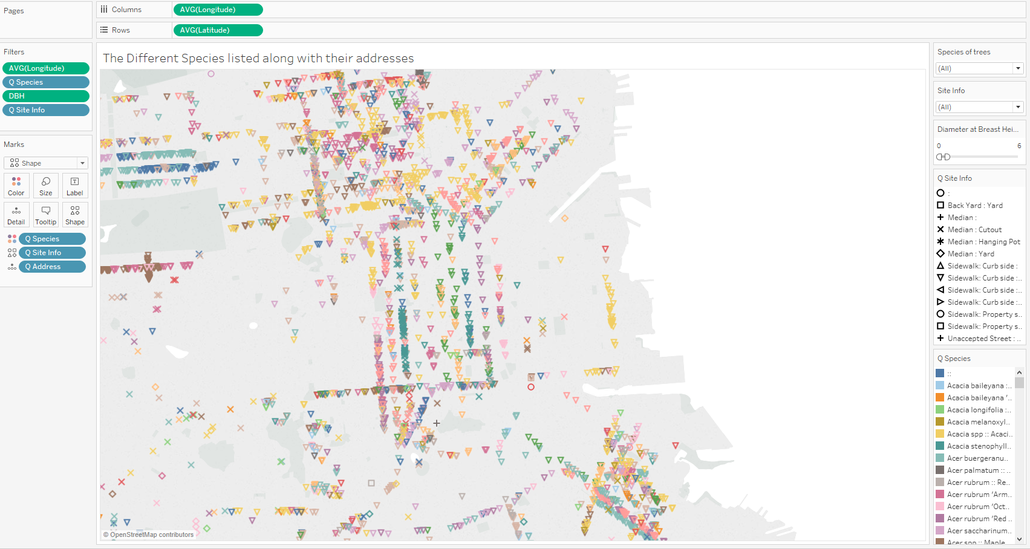

The above image displays the visualization of different Species and Site Info using different shapes and colors

**Abstract/Elaborate:**

The visualization system allows users to operate on different sections of the dashboard along with the option to zoom through the visualizations to elaborate the contents for a better understanding when dealing with larger data sets.

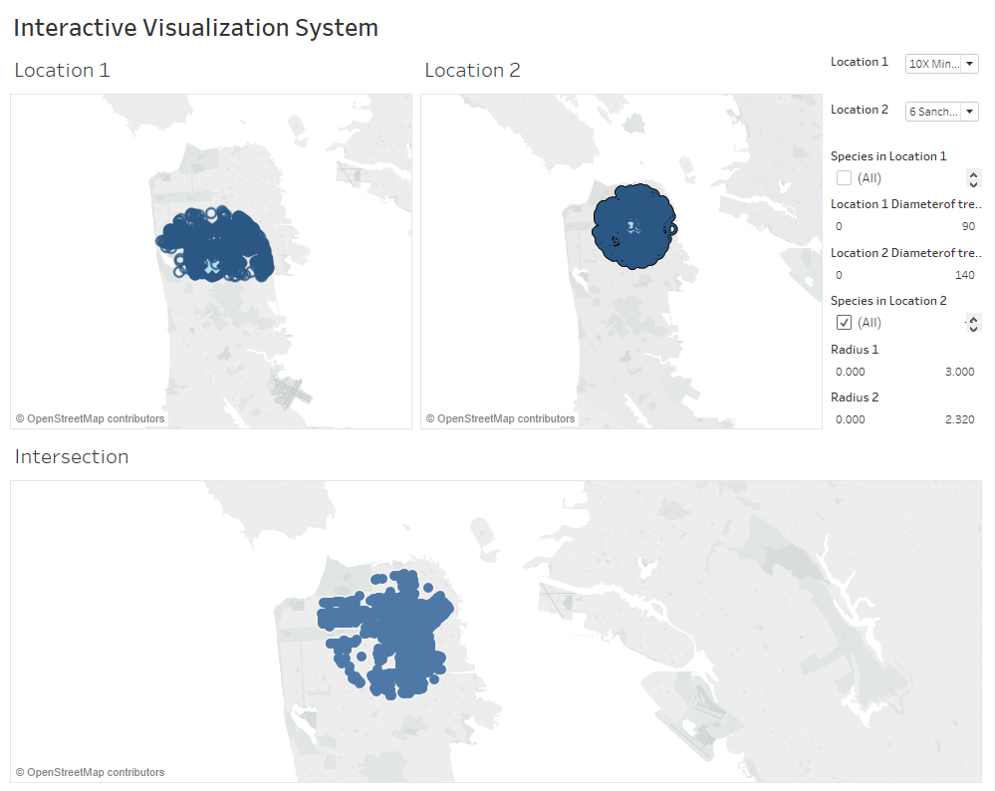

The above image shows the different sections of the Visualization system

**Filter:**  
  
The Visulaization system allows users to filter through a lot of filters such as the Addresses, Radius, Species, Diameter of the tree, Site Info etc. The list under the Filter section are all filters that facilitate the users to refine data and look only at what they wish to look at. The image belows displays the visualization created with filters applied along with the filter imformation being displayed on the right section of the image.

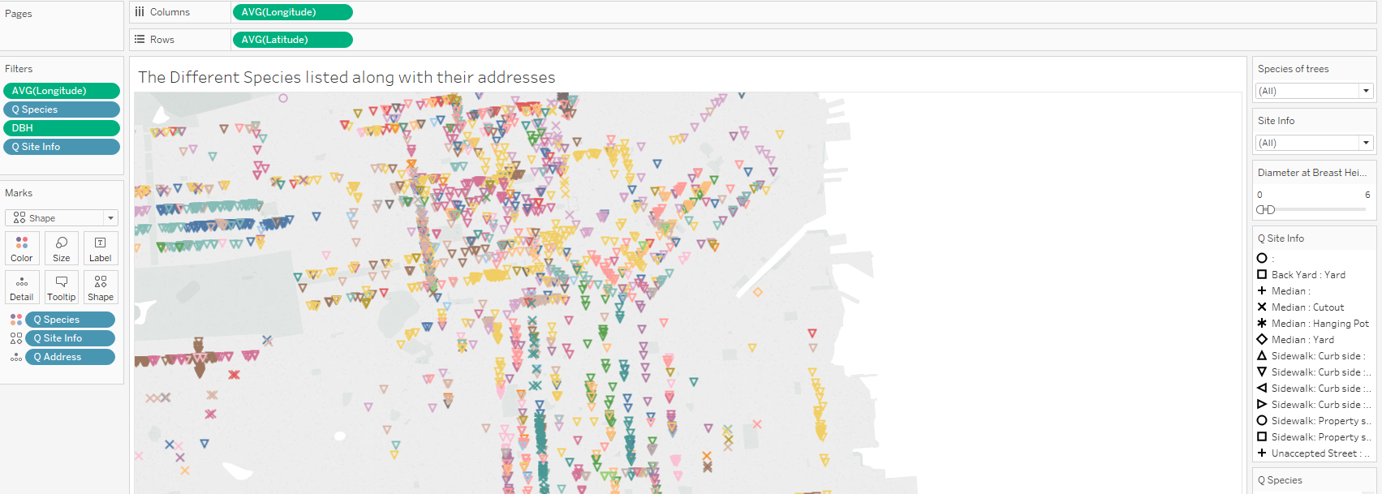  
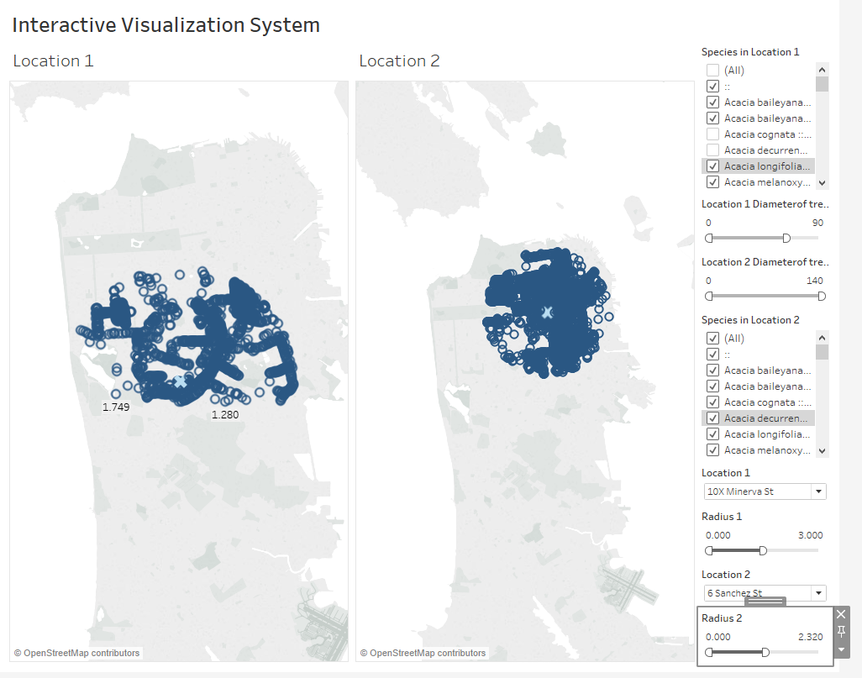  
The above image shows the Visualization system along with it its functional filters.

**Connect:**  
  
The Visualization system allows user to find out the intersection relation of the two locations when users specify the locations and radius using filters and adding them to the sets. The sheet “The Different Species listed along with their addresses with additional filters” provides functionality to sort all the trees based on species and Site Info which helps the users to look at only the related item instead of screening through large heaps of data. The below images show the visualizations created by implementing the intersection function between two sets and the visualizations of only the related Site Info.

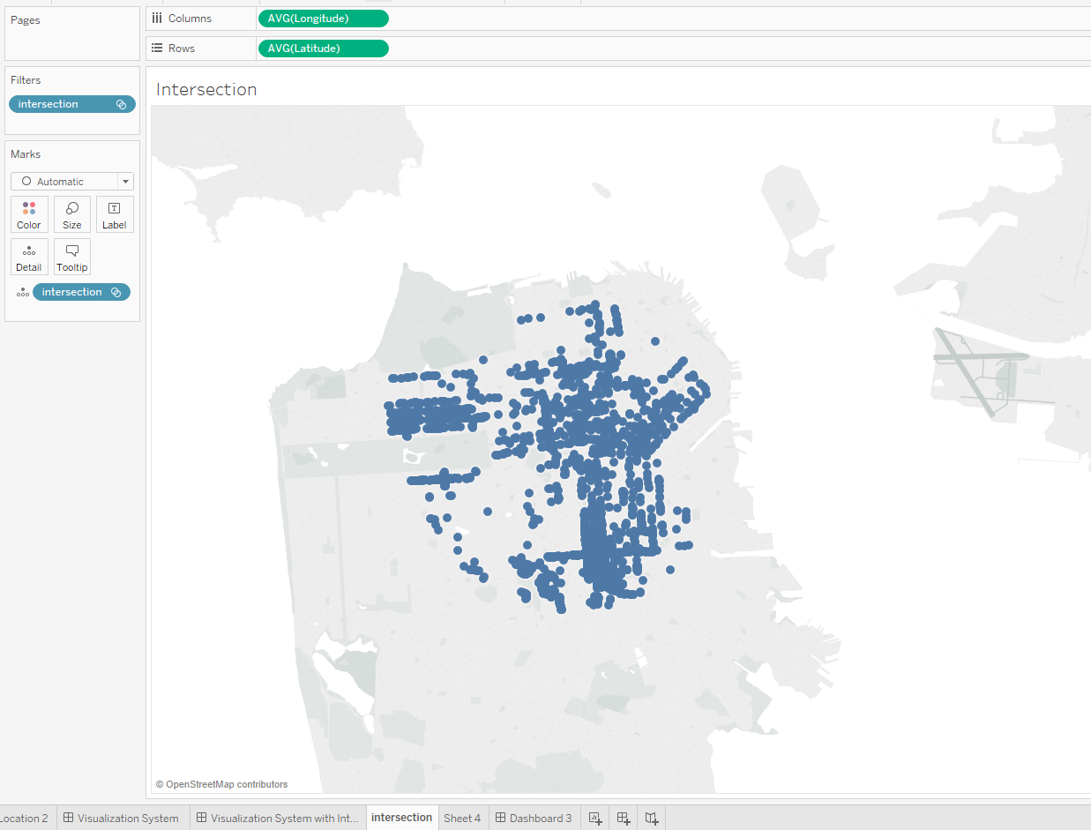

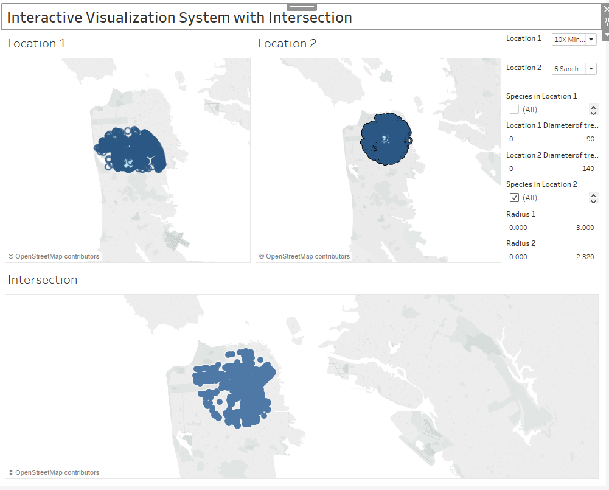

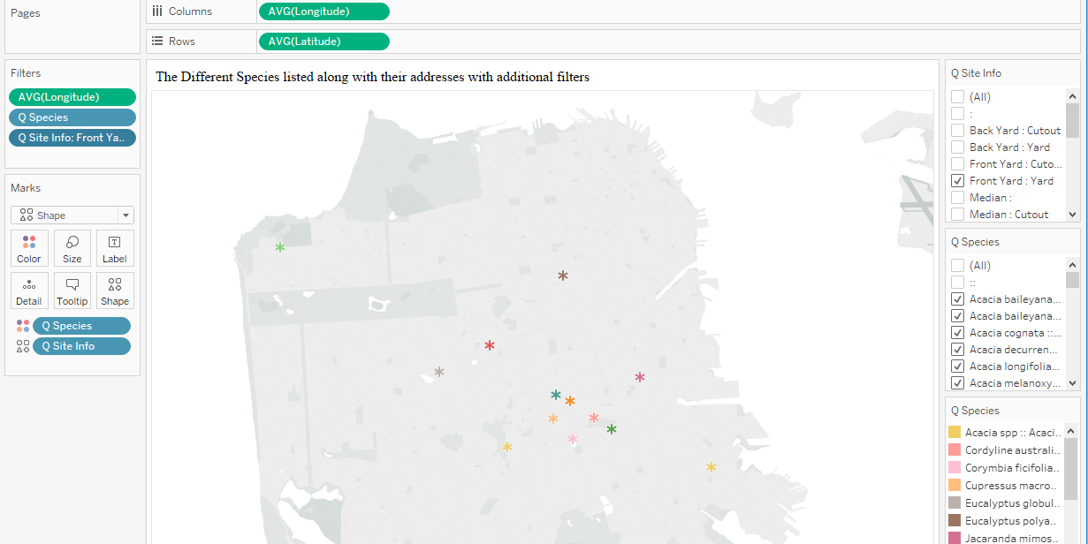

**References:**  
  
<https://onlinehelp.tableau.com/current/pro/desktop/en-us/sortgroup_sets_create.htm#dynamic>  
<https://community.tableau.com/thread/132845>